Sean Rettig
2015-04-16
ROB 421
Group 1

Individual Lab Report

So far, I have contributed primarily to the computer vision, remote control, and computer-microcontroller communication aspects of our robot, whilst also maintaining the project website and providing general support to the rest of the team as we designed, built, and tested our robot.
Today, I was able to test communication between our microcontroller and our robot's computer and develop an API with Marty, our electrical engineer, so that we can each implement our respective sides of the communication protocol properly. This will allow the computer to send commands to the microcontroller (such as when to reload or shoot) and the microcontroller to report sensor data back to the computer.

With regards to computer vision, I have implemented basic white ellipse detection in OpenCV and Python that will be used to determine the location of cups automatically so that robot can modify its position and launch speed to aim at cups. This was tested in various levels of sunlight and reported fairly reliable results as long as the cup was not partially shadowed (additional work will be needed to fix this). Having never used OpenCV or any other computer vision software, there was naturally a bit of a learning curve, but this was accentuated by the lackluster documentation of OpenCV's Python bindings. Furthermore, while I was able to detect polygons, I was not able to find a built-in method for detecting whether a polygon is an ellipse within some margin of error, and so this had to be implemented on my own.

The webcam streaming to the remote control computer also ended up being harder than I expected, having never done any sort of video streaming before and especially not with OpenCV video. The various methods I tried either did not work or were not reliable/feasible for this project. Further research will be needed to get a reliable video feed to the remote controller.

These three main areas of computer vision, remote control, and computer-microcontroller communication make up the core of the computer's responsibilities and are ultimately responsible for how the robot functions on a high level; computer vision failure will lead to inaccurate shots, remote control failure may prevent us from even trying to shoot at all, and computer-microcontroller communication failure can lead to the robot being inaccurate, locking up, or even destroying itself.

My plans for the next week include implementing my end of our computer-microcontroller communication API and testing it to ensure that each sends and receives data properly. I also plan to continue researching and implementing the remote control and video streaming functionality so that we can control our robot remotely. The computer vision will be taking a back seat since we can still manually aim as long as the remote control is working.
Webcam image showing the automatic detection of the opening of a cup:
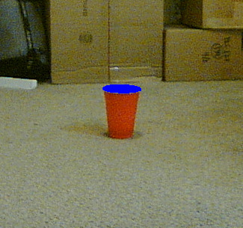

Initial test of ball landing locations from launcher prototype (it has since been modified):
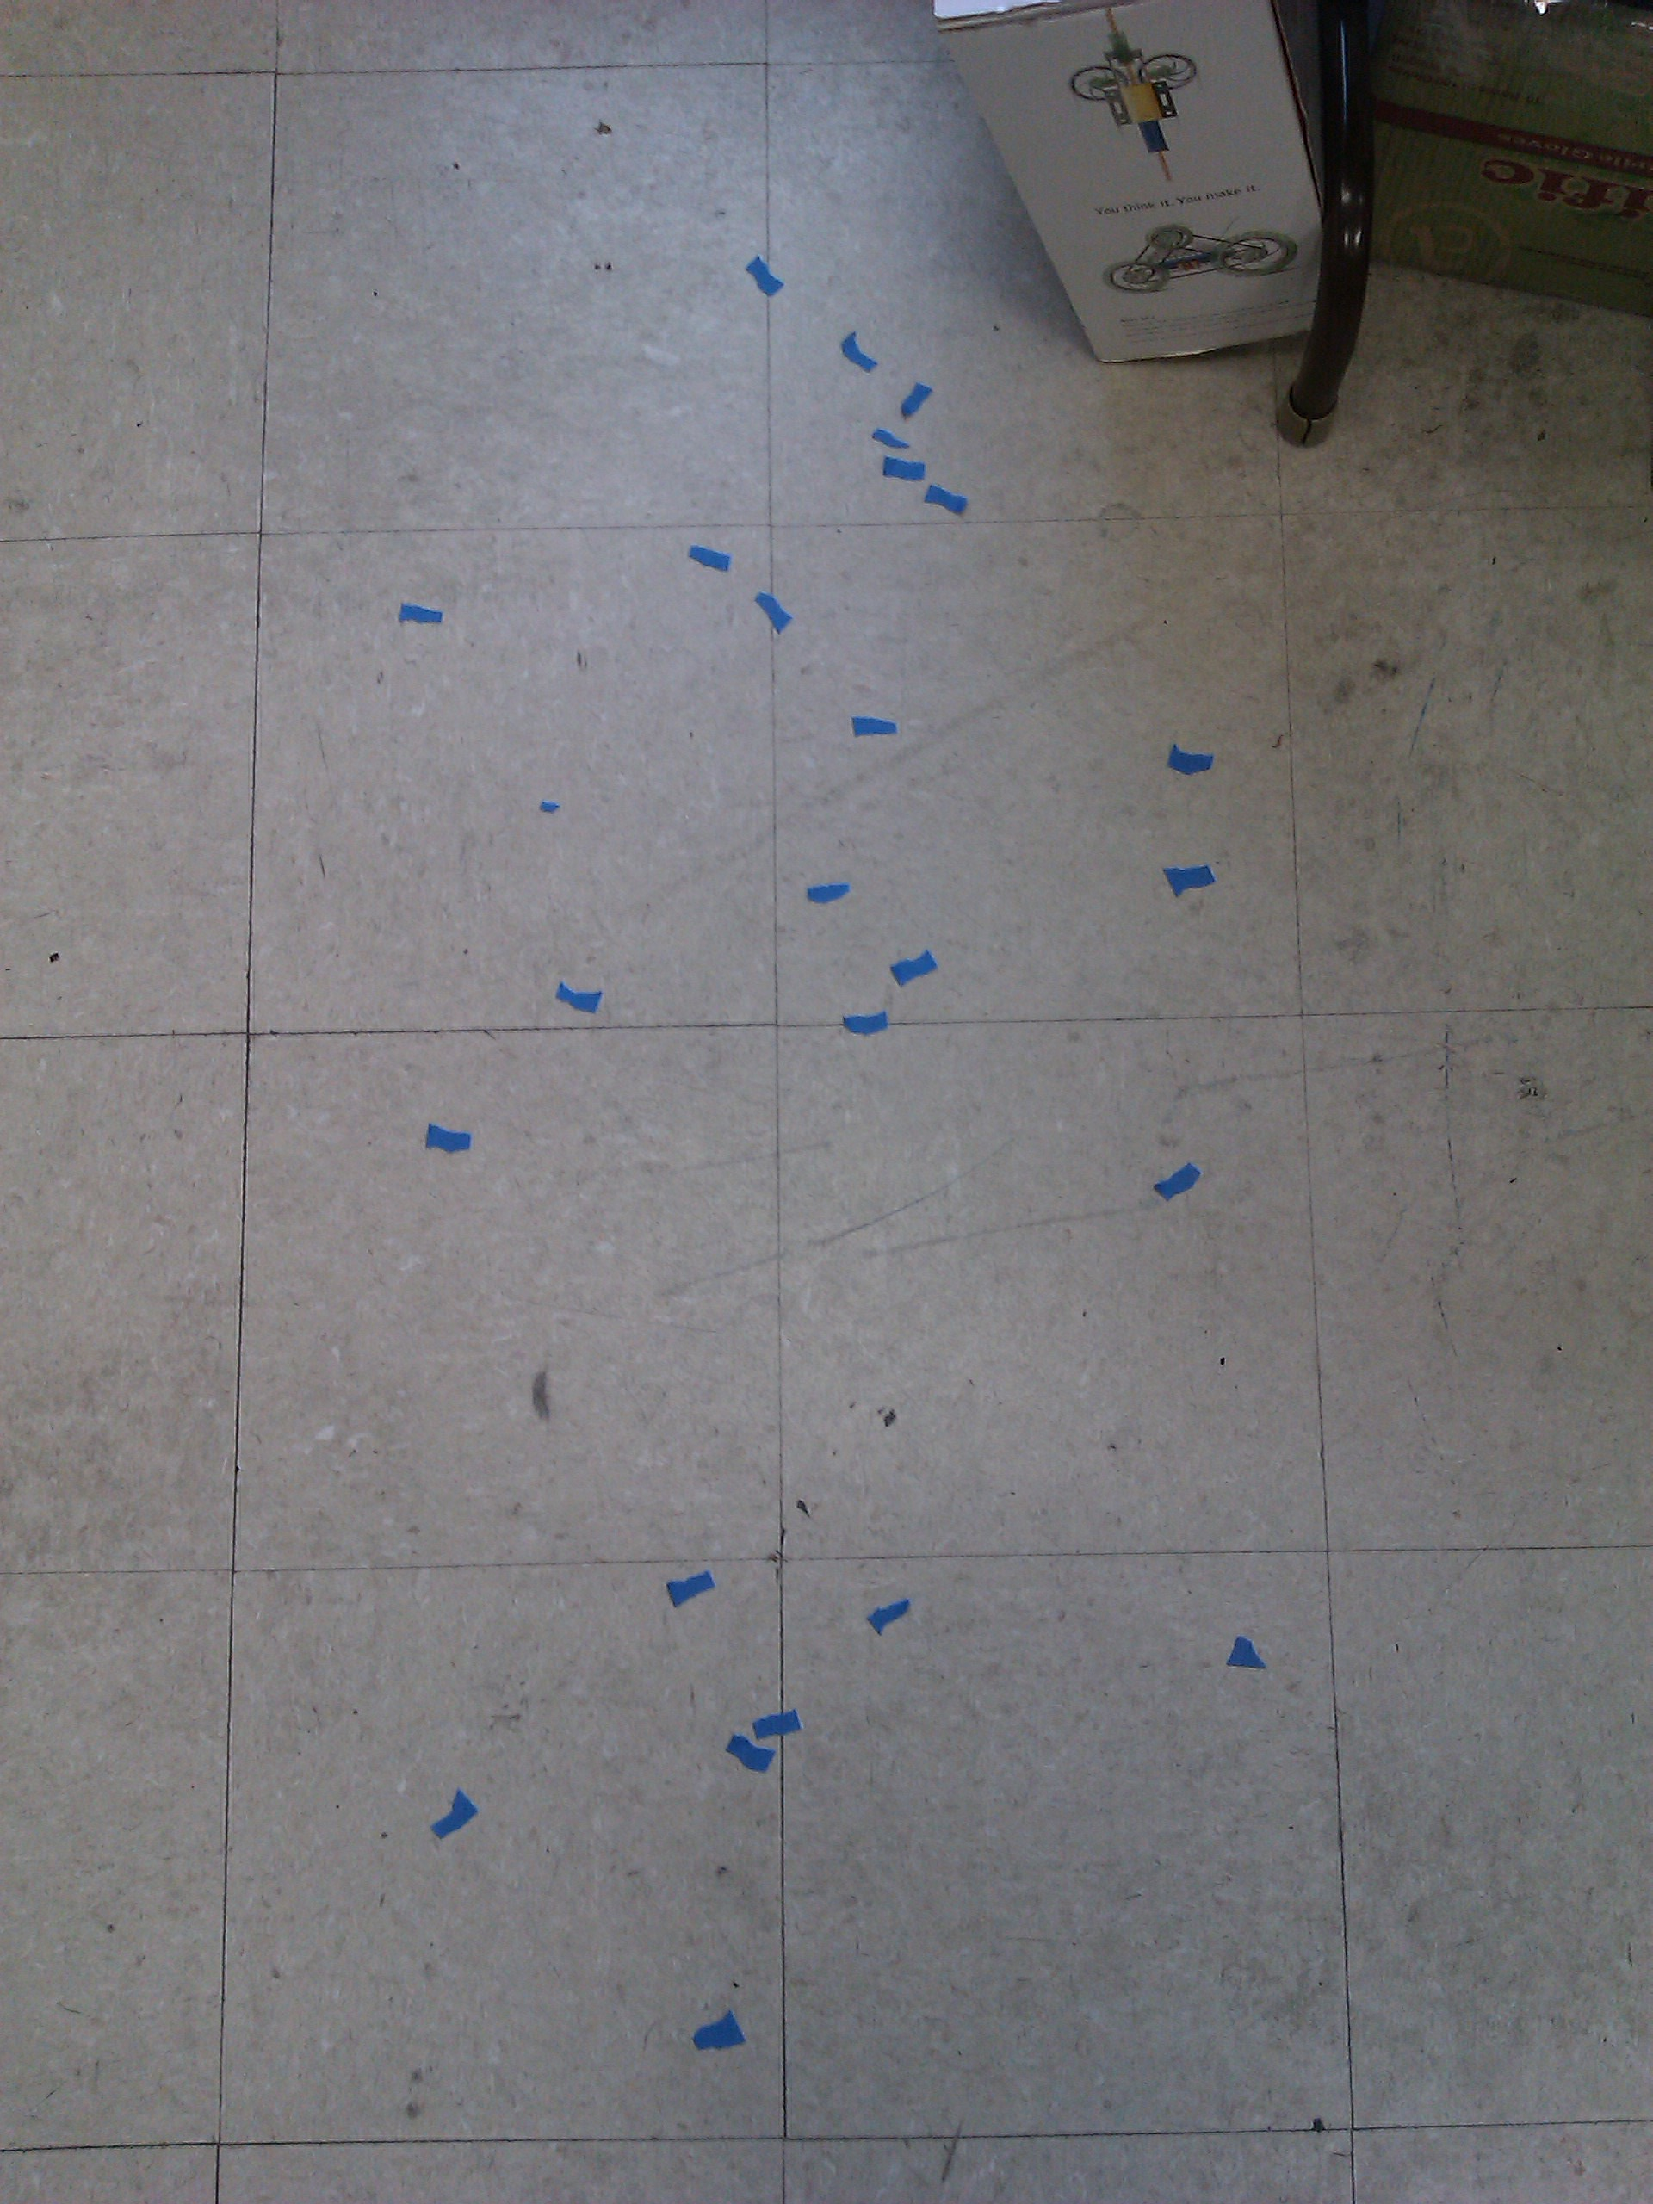

CAD model of current design (our actual robot looks just like this but isn't quite complete yet):
